Project - High Level Design
on
Rag-Chat-Bot
  - Course Name: Generative AI

Institution Name: Medicaps University – Datagami Skill Based Course

Student Name(s) & Enrolment Number(s):
Sr no | Student Name | Enrolment Number
1. | ADITYA AKOLKAR | EN22CS301047
2. | AMAN GURJAR | EN22CS301105
3. | Dazzele Dhalani | EN22CS301312
4. | AMAN MAKWANA | EN22CS301106
5. | ADITYA RAJ SISODIYA | EN22CS301063

Group Name: 02D1
Project Number: GAI-02
Industry Mentor Name:
University Mentor Name: Prof. Ajaj Khan
Academic Year: 2026

Table of Contents
- Introduction.
  - Scope of the document.
  - Intended Audience
  - System overview.
- System Design.
  - Application Design
  - Process Flow.
  - Information Flow.
  - Components Design
  - Key Design Considerations
  - API Catalogue.
- Data Design.
  - Data Model
  - Data Access Mechanism
  - Data Retention Policies
  - Data Migration
- Interfaces
- State and Session Management
- Caching
- Non-Functional Requirements
  - Security Aspects
  - Performance Aspects
- References

1. Introduction:
1.1 Scope of the document
• Defines the high-level architecture of the Healthcare Generative AI system
• Focuses on AI-based medical document generation using RAG and LLM models
• Covers major components: React frontend, FastAPI services, RAG engine, safety module, and MongoDB
• Describes document generation and retrieval workflows
• Explains overall data flow and system integrations

1.2 Intended Audience
• Healthcare professionals (doctors, clinicians)
• Patients using AI-generated health documents
• Hospital and clinic management
• Organizations adopting Generative AI in healthcare systems

1.3 System Overview
• Healthcare Generative AI system designed to generate medical and educational documents
• Uses Retrieval-Augmented Generation (RAG) with Large Language Models (LLMs)
• Retrieves verified medical knowledge from structured datasets before generation
• Generates documents such as disease overviews, health suggestions, educational notes, and draft medical certificates
• Applies safety and compliance checks before delivering output
• Stores generated documents securely and allows retrieval using unique Document ID
• Ensures privacy-first access and controlled medical content generation

2. System Design:

2.1 Application Design
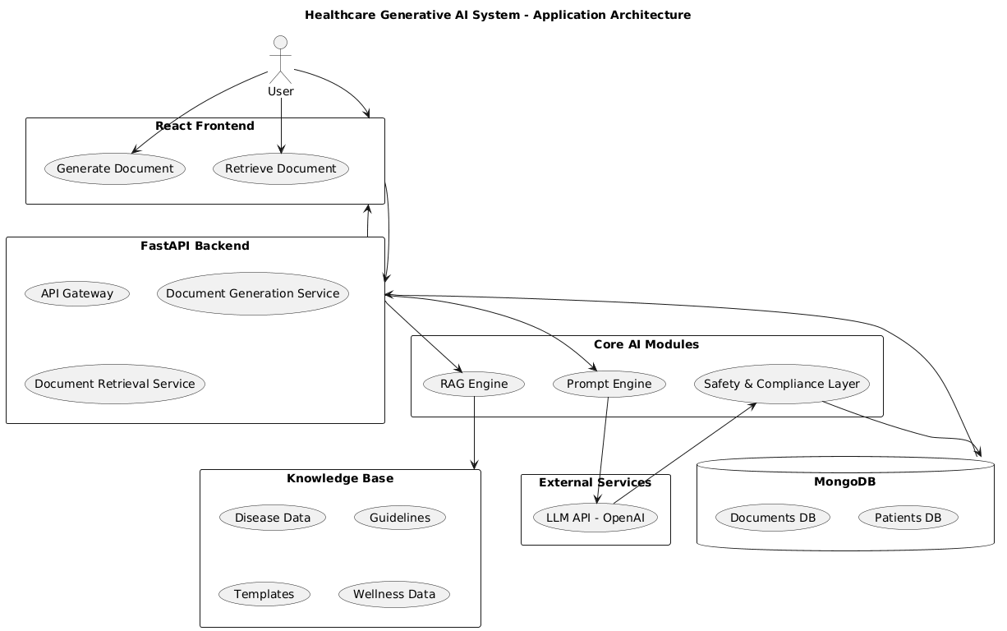

• React-based application used for document generation and retrieval
• FastAPI handles API requests and system logic
• RAG engine retrieves relevant medical knowledge from the dataset
• Prompt engine and LLM generate AI-based medical content
• Safety layer and MongoDB ensure secure storage and compliant output

2.2 Process Flow

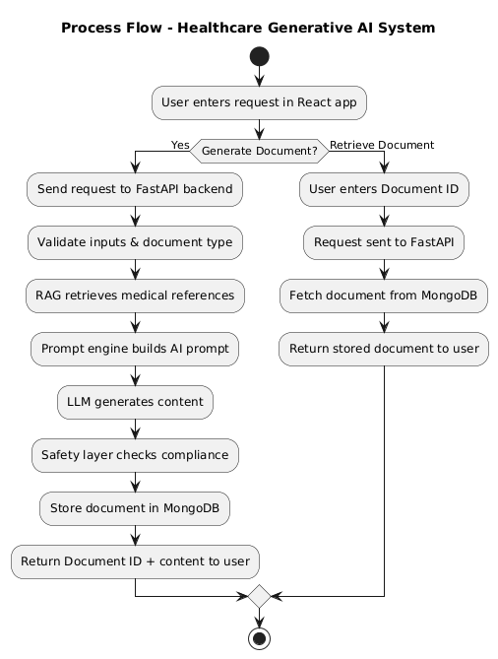

• User submits request to generate or retrieve a document through the React application
• FastAPI processes the request and validates inputs
• RAG engine retrieves relevant medical knowledge from the dataset
• Prompt engine and LLM generate AI-based document content
• Safety layer checks compliance and filters unsafe content
• Generated document is stored in MongoDB with a unique Document ID
• Document is returned to the user or retrieved later using the Document ID

2.3 Information flow
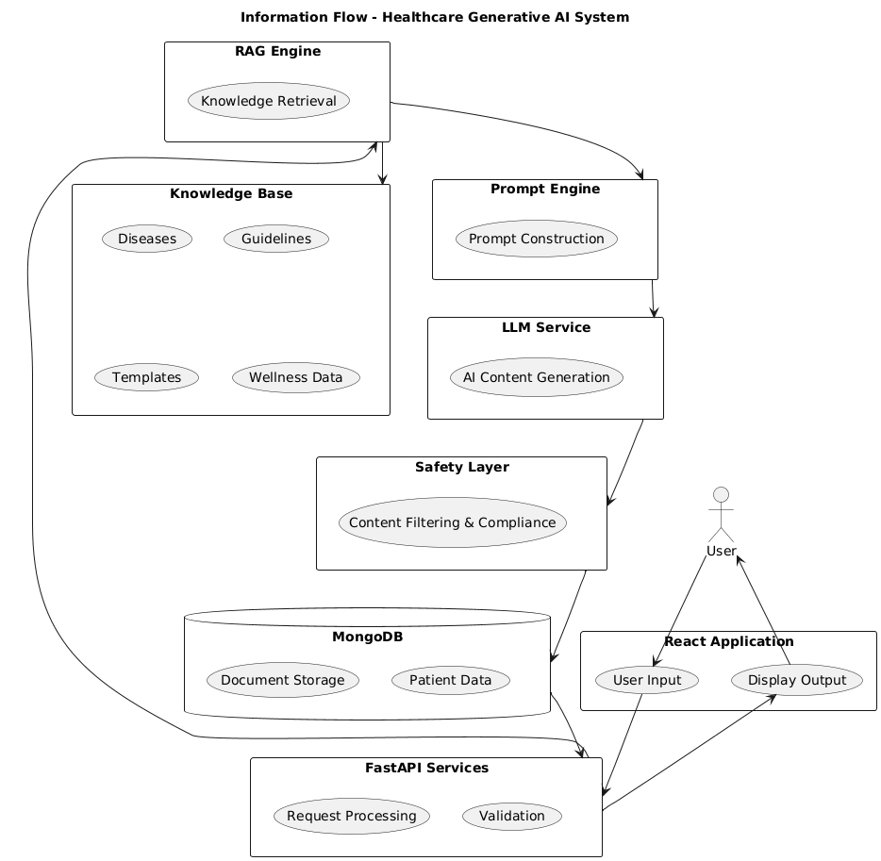

• User request is sent from the React application to FastAPI services
• RAG engine retrieves relevant medical data from the knowledge base
• Prompt engine and LLM generate the required document content
• Safety layer validates and filters the generated information
• Final document is stored in MongoDB and returned to the user

2.4 Components Design

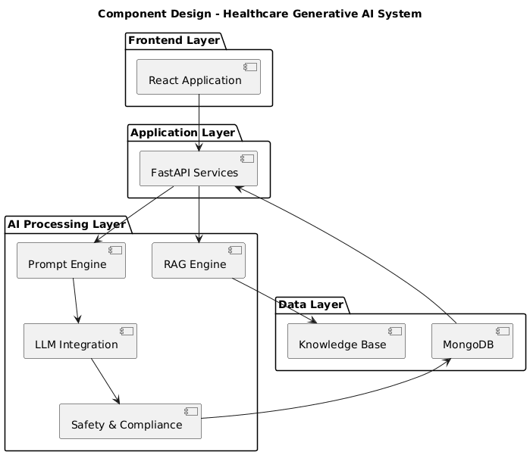

• React application handles user interaction and requests
• FastAPI manages application logic and API processing
• RAG, Prompt Engine, and LLM handle AI-based document generation
• Safety module ensures compliance and secure output
• MongoDB and Knowledge Base manage document and medical data storage

2.5 Key Design Considerations
• Privacy-first approach with document access only through unique Document ID
• Use of RAG to ensure generation from verified medical knowledge sources
• Safety and compliance layer to prevent unsafe or incorrect medical content

• Modular architecture for scalability and future enhancements
• Secure storage of documents and patient data using MongoDB

2.6 API Catalogue
• /api/generate – Generates AI-based medical documents using RAG and LLM
• /api/document/{document_id} – Retrieves document using unique Document ID
• /api/patients – Creates new patient record in the system
• /api/patients/{hospital_id} – Fetches list of patients for a hospital
• /api/document-types – Provides available document types and requirements
• / – Health check endpoint to verify system status

3. Data Design.

3.1 Data Model

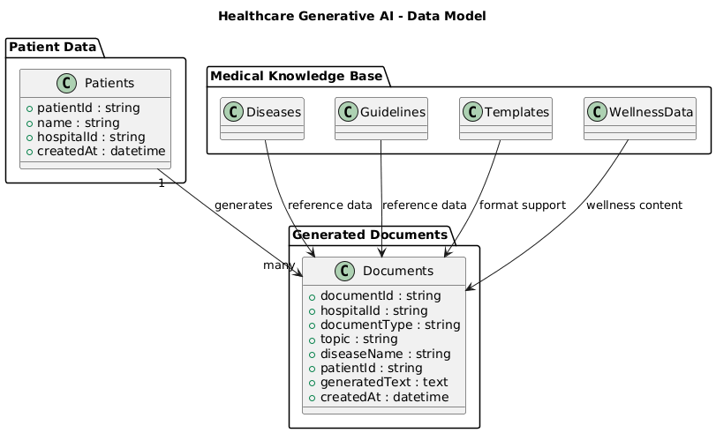

• Data is stored in MongoDB using structured collections for scalability
• Main entities include Patients, Documents, and Medical Knowledge Base
• Each patient can have multiple generated documents
• Knowledge base data (diseases, guidelines, templates, wellness) supports AI document generation
• Document records store generated content, type, hospital ID, and timestamp for tracking and retrieval

3.2 Data Access Mechanism

• Data access is handled through FastAPI-based API endpoints
• MongoDB is used for storing and retrieving patient and document data
• RAG engine reads structured knowledge base files for content generation
• Prompt engine and AI modules access retrieved data for processing
• Secure read and write operations are performed before storing documents
• Document retrieval is allowed only through unique Document ID
• Access control ensures privacy and protection of medical information

3.3 Data Retention Policies
• Generated documents are stored securely in MongoDB for future retrieval
• Documents are accessible only through unique Document ID to maintain privacy
• Patient-related data is stored only for system functionality and tracking
• No unnecessary personal medical information is retained in the system
• Data retention follows privacy-focused and secure storage practices
• Old or unused data can be archived or deleted as per organizational policies
3.4 Data Migration
• Data migration allows transfer of records when system upgrades or database changes occur
• Supports movement of patient and document data between database versions
• Ensures data consistency and integrity during migration process
• Backup mechanisms are maintained before performing migration
• Migration supports scalability and future system expansion
• Enables integration with new storage systems or cloud platforms if required

4. Interfaces
4.1 User interface:

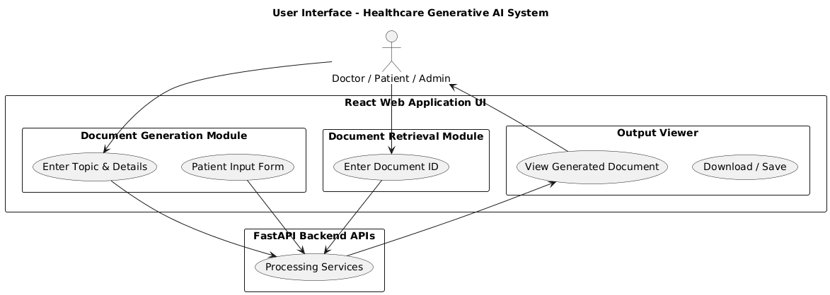

• React web application provides an easy and interactive user experience
• Separate modules for document generation and document retrieval
• Patient details and document topics collected through structured forms
• Generated documents displayed in a clear output viewer interface
• UI communicates with FastAPI backend through secure API requests

4.2 API interface
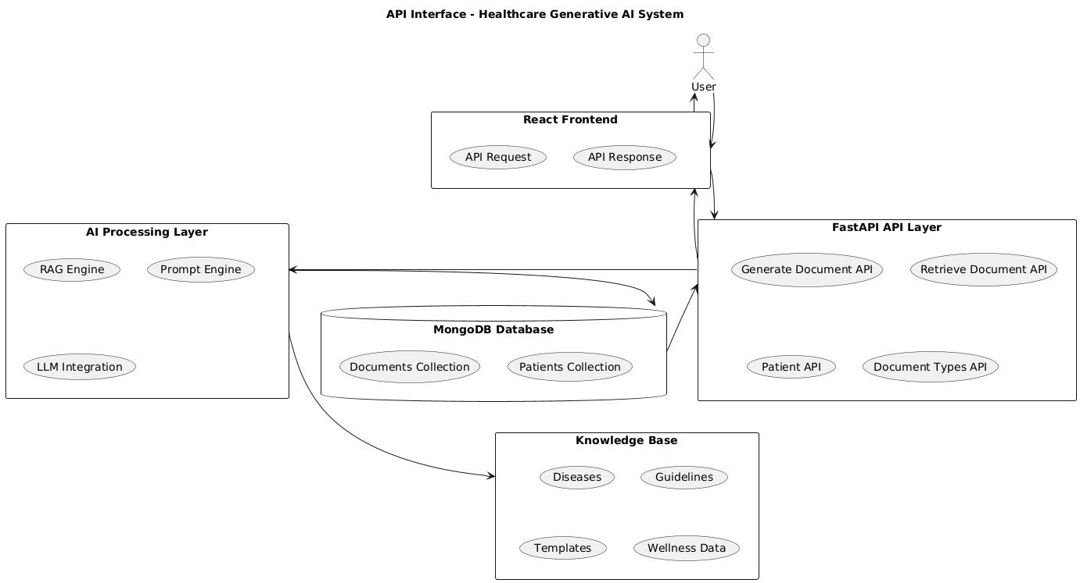

• React frontend communicates with backend through REST APIs
• FastAPI acts as the central API handling layer
• APIs interact with AI modules for document generation
• MongoDB stores and retrieves patient and document data
• Knowledge base is accessed through RAG during API processing

4.3 AI/ML INTERFACE
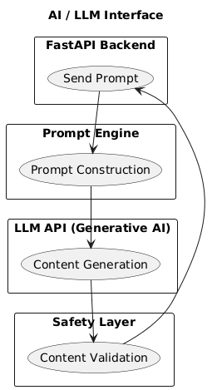

• Integration with external Generative AI (LLM API)
• Prompt engine prepares structured input for AI model
• LLM generates medical and educational content
• Safety layer validates generated output
• Ensures reliable and controlled AI-based document generation

4.4 Database interface
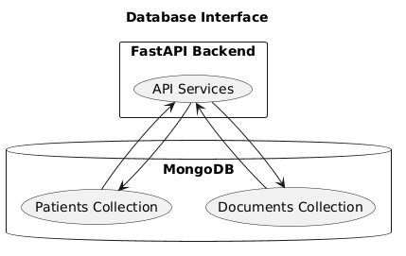
• MongoDB used for storing patient and document data
• Backend APIs perform read and write operations
• Supports secure and scalable data storage
• Enables document retrieval using Document ID
• Maintains structured storage for system records

4.5 Knowledge Base Interface

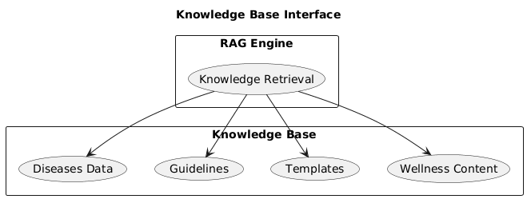

• Provides structured medical information for document generation
• Includes diseases, guidelines, templates, and wellness content
• Accessed by RAG engine during retrieval process
• Ensures content generation from verified knowledge sources
• Supports accurate and domain-specific AI output

5. State and session management

• Application manages state during document generation and retrieval processes
• React frontend maintains temporary user input and interaction state
• Backend processes each request independently using stateless APIs
• Document ID is used to maintain session reference for generated documents
• MongoDB stores persistent data such as patients and generated documents
• No long-term user session is stored to ensure privacy and security

6. Caching
• Caching helps reduce repeated processing and improves system response time
• Frequently accessed medical knowledge data can be cached for faster retrieval
• Generated document responses may be temporarily cached to avoid regeneration
• Backend services manage temporary storage of request and retrieval data
• Caching reduces load on AI models and database operations
• Ensures efficient and scalable system performance

7. Non-Functional Requirements
7.1 Security Aspects
• Privacy-first design with document access only through unique Document ID
• Secure API communication between frontend and backend services
• Controlled access to patient and document data in MongoDB
• Safety layer prevents unsafe or misleading medical content generation
• No sensitive personal medical data exposed through the system
7.2 Performance Aspects
• Fast document generation using optimized RAG and LLM processing
• Efficient data retrieval from MongoDB for quick response time
• Caching reduces repeated processing and improves system speed
• Scalable architecture supports multiple users simultaneously
• Optimized API communication ensures smooth system performance

References
• FastAPI Documentation – for backend API development
• MongoDB Documentation – for database design and data management
• React Documentation – for frontend application development
• FAISS and Sentence Transformers – for vector search and RAG implementation
• Generative AI / LLM API Documentation – for AI-based content generation
• Healthcare content guidelines and medical reference materials used in knowledge base

